**Team 1 – Stage 1 Summary**

**Topic/Purpose of the Website**

We want the customer to learn about our web development company and its strengths when visiting our website, and, from that, be convinced to purchase our services.

**Target Audience**

Potential clients, including small to medium sized businesses, should visit our website when looking for web development companies to take on their project(s). They may be of any age.

**Roles & Responsibilities**

-Each team member will work on their own individual page showcasing them and their strengths as a developer. Each of us will make our collective contributions to the home/landing page of the company’s website. **ETA:** Project due date

-Samuel (subject to change) will create the company’s/website’s logo. **ETA:** About a week

-Each person will also handle their own page’s CSS styling/stylesheet. Additionally, we will all collectively manage the styling of the home/landing page. This will all likely be done after the main drafting phase has been done for each page to have a more accurate overview.

-Cameron and I (Nicolas) have configured the hosting through GitHub Pages.

-Likely Cameron and I (if not all of us) will perform all testing at various stages.

-As the team leader, I (Nicolas) will verify that the website meets requirements and our own creativity standards.

-Also as the team leader, I will plan, with the input of all team members, the website and create its story-line.

-We have already decided on Git/GitHub for our project coordination efforts as it combines hosting, collaboration, and version control all in one.

**Site Map**

Website Organization: Hierarchical

To keep it simple, the home page is the landing page and description of our web development company. Each subpage is the showcase of a developer (each of us).

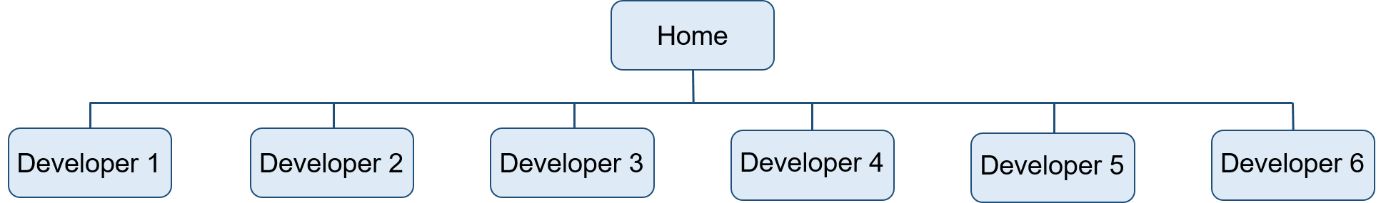

Page Layout(s): Most likely single column, but the homepage and developer pages may differ and it’s all subject to change as this is the early phase

**Domain Name**

<camjohn2000.github.io>